Department of Computer Science
Faculty of Computing
Sri Lanka Institute of Information Technology

IT3021: Data Warehousing and Business Intelligence
Year 3 Semester 2 | 2026

Assignment 1
Electricity Spot Trade Settlement – Data Warehouse & ETL Development

Table of Contents

Table of Contents 1
1. Introduction 2
2. Task 1 – Dataset Selection 3
2.1 Dataset Description 4
2.2 Business Process Explanation 4
2.3 Dataset Attributes 4
2.4 Entity Relationship Diagram (ERD) 5
3. Task 2 – Preparation of Data Sources 5
3.1 Overview of Data Source Preparation 6
3.2 Data Source Mapping Table 6
3.3 Description of Each Data Source 6
Source 1 – Market Participants (CSV) 6
Source 2 – Security Protocols (JSON) 6
Source 3 – Network Slice Data (Excel) 6
Source 4 – Energy Sources (TXT) 7
Source 5 – Core Spot Trade Transactions (SQL Server) 7
3.4 Enrichment and Hierarchy Planning 7
4. Task 3 – Solution Architecture 7
4.1 Architecture Overview 8
4.2 DW & BI Architecture Diagram 8
4.3 Description of Each Layer 8
5. Task 4 – Data Warehouse Design & Development 8
5.1 Dimensional Model Overview 9
5.2 Fact Table – Grain Definition 9
5.3 Dimension Tables 9
5.4 Slowly Changing Dimension (SCD) 10
5.5 Star Schema Diagram 10
5.6 SQL Server Implementation 10
5.7 Design Assumptions 11
6. Task 5 – ETL Development 11
6.1 ETL Architecture Overview 12
6.2 ETL Load Order 12
6.3 SSIS Control Flow 12
6.4 Data Extraction – Source Components 13
6.5 Slowly Changing Dimension – SCD Type 2 Implementation 13
6.6 Fact Table Load – Lookup Transformations 13
6.7 Derived Column – accm_txn_create_time 14
6.8 ETL Execution and Validation 14
7. Task 6 – ETL Development: Accumulating Fact Table Update 15
7.1 Accumulating Fact Table Concept 16
7.2 Schema Extension – SQL 16
7.3 Input Dataset – Completed Transactions 16
7.4 Update Package – Architecture 17
7.5 Update Data Flow – OLE DB Command 17
7.6 Pre- and Post-Update Validation 18
8. Conclusion 19

1. Introduction
This report documents the complete design and implementation of a Data Warehouse (DW) and Business Intelligence (BI) solution for the Electricity Spot Trade Settlement system, developed as part of the IT3021 Data Warehousing and Business Intelligence module.
The solution is built using Microsoft SQL Server and SQL Server Integration Services (SSIS), and covers all six tasks outlined in Assignment 1: dataset selection, data source preparation, solution architecture design, dimensional modelling, ETL development, and accumulating fact table updates.

2. Task 1 – Dataset Selection

2.1 Dataset Description
The dataset selected for this project is the Secure Energy Transactions (Electricity Spot Trade Settlement) dataset. This dataset represents a transactional OLTP system used to record electricity spot trading activities between participants in an energy market.
Electricity spot markets allow participants such as energy generators, dealers, and consumers to buy or sell electricity in real time based on market demand and supply. The dataset captures high-frequency electricity trading transactions that occur between these market participants through a digital trading platform.
Each transaction record contains detailed information including:
- Transaction timestamp
- Electricity quantity traded (MWh)
- Price per megawatt-hour (MWh)
- Total transaction cost
- Network latency
- Security configuration
- Transaction status

The dataset contains approximately 10,000–150,000 transaction records, representing around one year of electricity trading activity. This is sufficient to demonstrate dimensional modelling, ETL processes, hierarchies, OLAP analysis, and business intelligence reporting.

2.2 Business Process Explanation
The selected dataset models the electricity spot market trading process, where electricity is bought and sold between different market participants in real time. Energy producers generate electricity and sell it through the trading platform. Dealers may act as intermediaries, while consumers purchase electricity to meet their demand.
When a participant initiates a trade, the system records a transaction containing:
- The user performing the transaction
- Transaction type (buy or sell)
- Electricity quantity traded
- Price per megawatt-hour
- Total transaction cost

The system also records technical infrastructure details associated with each transaction including network latency, network slice used for communication, and security configuration. Security protocols such as encryption methods and Zero Trust authentication are applied to ensure secure data transmission.

2.3 Dataset Attributes

Attribute | Description
transaction_id | Unique identifier for each electricity trading transaction
timestamp | Date and time when the transaction occurred
user_id | Identifier of the participant
user_role | Role of the user (generator, dealer, consumer)
transaction_type | Type of trade (buy or sell)
electricity_quantity | Amount of electricity traded (MWh)
price_per_mwh | Price per megawatt-hour
total_cost | Total cost of the transaction
latency_ms | Network latency during transaction (milliseconds)
security_level | Security configuration level
encryption_method | Encryption method used
zt_authentication | Indicates whether Zero Trust authentication was used
network_slice_id | Network slice used for communication
transaction_status | Status of the transaction (e.g., completed, pending)

2.4 Entity Relationship Diagram (ERD)
The ER diagram below illustrates the relationships between the main entities in the electricity trading platform. The Transaction entity represents electricity trade events and connects to the User, Network Slice, Security Configuration, and Energy Source entities through foreign key relationships.

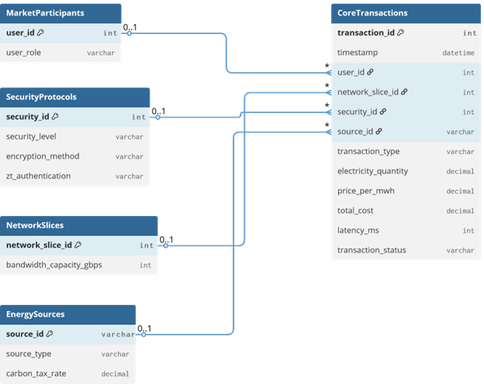
Figure 1 – OLTP Entity Relationship Diagram (ERD)

3. Task 2 – Preparation of Data Sources

3.1 Overview of Data Source Preparation
In enterprise systems, data is often distributed across multiple systems and stored in different formats. To simulate this real-world environment, the original dataset was reorganised into multiple heterogeneous data sources. This approach demonstrates the ability of data warehousing systems to integrate data from different platforms during the ETL process.

3.2 Data Source Mapping Table

Source Name | Format | Description
Market Participants | CSV | Stores user roles and participant information
Security Protocols | JSON | Stores security configurations applied to transactions
Network Slices | Excel (.xlsx) | Stores network infrastructure and bandwidth data
Energy Sources | TXT | Stores electricity generation types and carbon tax rates
Spot Trade Transactions | SQL Server Table | Core transaction records (primary OLTP source)

3.3 Description of Each Data Source

Source 1 – Market Participants (CSV)
This CSV file contains information about participants in the electricity trading system. It includes the following attributes:
- user_id – unique identifier for each participant
- user_role – role of the participant (generator, dealer, consumer)

Source 2 – Security Protocols (JSON)
This JSON file contains security configurations applied during transactions. It includes:
- security_id – unique security configuration identifier
- security_level – level of security applied
- encryption_method – encryption algorithm used
- zt_authentication – whether Zero Trust authentication was applied

Source 3 – Network Slice Data (Excel)
This Excel file represents network infrastructure data used during trading transactions. It includes:
- network_slice_id – unique identifier for the network slice
- bandwidth_capacity_gbps – bandwidth capacity in gigabits per second

Source 4 – Energy Sources (TXT)
This text file stores electricity generation source details and environmental attributes. It includes:
- source_id – unique identifier for the energy source
- source_type – type of energy generation (e.g., solar, wind, hydro)
- carbon_tax_rate – environmental carbon tax rate for the source type

Source 5 – Core Spot Trade Transactions (SQL Server)
This SQL Server table represents the primary operational OLTP data source containing all electricity trade transaction records. It includes: transaction_id, timestamp, user_id, network_slice_id, security_id, source_id, transaction_type, electricity_quantity, price_per_mwh, total_cost, latency_ms, and transaction_status.

3.4 Enrichment and Hierarchy Planning
The Energy Sources dataset was introduced as an additional enrichment source to provide environmental and hierarchical context. This allows the data warehouse to support category-level hierarchies (Energy Category → Source Type) which are not present in the original transaction data.
Similarly, the User Role information is maintained separately from the core transaction data to support the Participant → Role hierarchy in dimensional analysis.

4. Task 3 – Solution Architecture

4.1 Architecture Overview
A Data Warehouse and Business Intelligence architecture was designed to integrate electricity trading data from multiple heterogeneous sources and transform it into a centralised analytical repository. The architecture consists of five layers:
- Data Source Layer – Multiple raw data sources in different formats
- Staging Layer – Temporary storage for cleansing and validation
- ETL Processing Layer – SSIS packages for extraction, transformation, and loading
- Data Warehouse Layer – Centralised dimensional model (SQL Server)
- OLAP and Reporting Layer – Analytical cubes and BI dashboards

4.2 DW & BI Architecture Diagram
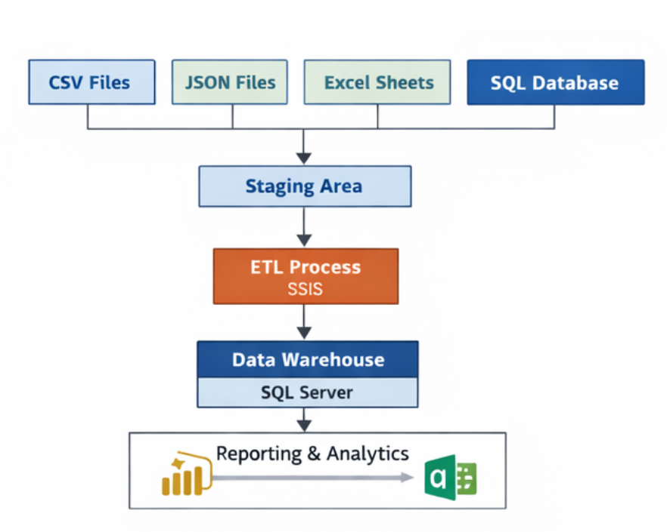
Figure 2 – DW & BI Solution Architecture

4.3 Description of Each Layer

Layer | Component | Description
Data Source Layer | CSV, JSON, Excel, TXT, SQL Server | Operational systems and files generating raw electricity trading data
Staging Layer | Staging Tables in SQL Server | Temporary storage for raw data; used for cleansing, validation, and deduplication before DW load
ETL Layer | SSIS (SQL Server Integration Services) | Extracts data from all sources, applies transformations such as data type conversion, SCD handling, and surrogate key lookup, then loads into the DW
Data Warehouse Layer | SQL Server DW Database | Central dimensional repository optimised for analytical queries; contains fact and dimension tables
OLAP & Reporting Layer | SSAS, Power BI, Excel | Analytical tools connected to the DW for multidimensional analysis, dashboards, and business reporting

5. Task 4 – Data Warehouse Design & Development

5.1 Dimensional Model Overview
The data warehouse is designed using a Star Schema to support analytical queries related to electricity trading activities. The central fact table, Fact_Electricity_Transaction, stores measurable transaction data such as electricity quantity, transaction cost, and network latency.
All dimension tables connect directly to the fact table with no inter-dimension relationships, following the classic Star Schema design.

5.2 Fact Table – Grain Definition
The grain of the Fact_Electricity_Transaction table is defined as:
One row represents one electricity spot trade transaction executed in the trading system.
This ensures the highest level of detail for analytical processing.

Key measures stored in the fact table:

Measure | Data Type | Description
ElectricityQuantity | DECIMAL(10,2) | Amount of electricity traded in MWh
PricePerMwh | DECIMAL(10,2) | Price per megawatt-hour
TotalCost | DECIMAL(12,2) | Total monetary value of the transaction
LatencyMs | INT | Network latency in milliseconds

5.3 Dimension Tables

Dimension Table | Description | Hierarchy
Dim_Date | Stores date-related attributes for time-based analysis | Year → Quarter → Month → Day
Dim_Participant | Stores trading participant information including user role (generator, dealer, consumer) | Role → User
Dim_Participant | Stores user role types (generator, dealer, consumer) | – (leaf level)
Dim_Network_Slice | Stores network infrastructure details and bandwidth | –
Dim_Security_Protocol | Stores encryption methods and security configuration levels | –
Dim_Energy_Source | Stores electricity generation source types and carbon tax rates (SCD Type 2) | Category → Source Type

5.4 Slowly Changing Dimension (SCD)
The Dim_Energy_Source dimension is implemented as a Type 2 Slowly Changing Dimension (SCD Type 2). Carbon tax rates for energy sources may change over time due to regulatory updates. Instead of overwriting existing records, a new row is inserted to preserve the full history of changes.
The following columns support SCD Type 2 tracking:

Column | Purpose
ValidFrom | Date from which this version of the record became effective
ValidTo | Date on which this version expired (NULL for current record)
IsCurrent | Boolean flag indicating the currently active record (1 = current)

5.5 Star Schema Diagram
The relational diagram below shows the complete Star Schema implemented in SQL Server, including all dimension and fact tables and their relationships.

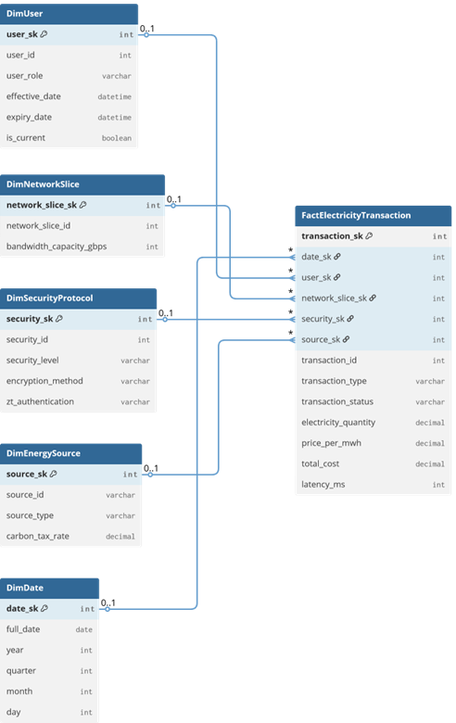

Figure 3 – Data Warehouse Star Schema

5.6 SQL Server Implementation
The data warehouse schema was implemented in SQL Server. Below are the key CREATE TABLE statements. Insert a screenshot of your SQL Server Management Studio (SSMS) showing the executed scripts and the resulting tables.

[ INSERT SCREENSHOT HERE ] ➜ Figure 4 – SSMS screenshot showing DW database with all created tables in Object Explorer

Figure 4 – SQL Server Implementation – DW Tables in SSMS

Example SQL – Fact Table with Accumulating Columns:
CREATE TABLE Fact_Electricity_Transaction (
TransactionSK INT IDENTITY(1,1) PRIMARY KEY,
DateSK INT NOT NULL,
ParticipantSK INT NOT NULL,
NetworkSliceSK INT NOT NULL,
SecurityProtocolSK INT NOT NULL,
EnergySourceSK INT NOT NULL,
TransactionID INT NOT NULL,
ElectricityQuantity DECIMAL(10,2),
PricePerMwh DECIMAL(10,2),
TotalCost DECIMAL(12,2),
LatencyMs INT,
TransactionType NVARCHAR(10),
TransactionStatus NVARCHAR(20),
accm_txn_create_time DATETIME DEFAULT GETDATE(),
accm_txn_complete_time DATETIME NULL,
txn_process_time_hours FLOAT NULL
);

5.7 Design Assumptions
- transaction_id is treated as the natural business key for all fact table lookups.
- Surrogate keys are generated using SQL Server IDENTITY columns for all dimension and fact tables.
- The Dim_Energy_Source dimension uses Type 2 SCD to track changes in carbon tax rates over time.
- The fact table uses transaction-level grain – one row per trade transaction.
- The Dim_Date table is pre-populated to cover the full date range of the dataset.
- Null or invalid records encountered during ETL are redirected to an error output rather than causing pipeline failure.

6. Task 5 – ETL Development

6.1 ETL Architecture Overview
The ETL solution was implemented using SQL Server Integration Services (SSIS) within Microsoft Visual Studio. The pipeline extracts data from five heterogeneous sources (CSV, JSON, Excel, TXT, and SQL Server), loads data into staging tables, performs transformations, and loads the cleaned data into the dimensional model.
The architecture follows three layers: Source Layer → Staging Layer → Data Warehouse Layer.

[ INSERT SCREENSHOT HERE ] ➜ Figure 5.1 – SSIS Project in Visual Studio Solution Explorer showing all packages and connection managers

Figure 5.1 – SSIS Project Structure in Visual Studio

6.2 ETL Load Order
To maintain referential integrity, dimension tables must be fully loaded before the fact table. The execution order is:

Step | Package Task | Target Table
1 | Truncate all staging tables | (Staging DB)
2 | Load Staging – Market Participants | StgMarketParticipant
3 | Load Staging – Security Protocols | StgSecurityProtocol
4 | Load Staging – Network Slices | StgNetworkSlice
5 | Load Staging – Energy Sources | StgEnergySource
6 | Load Staging – Core Transactions | StgEnergyTransaction
7 | Load Dim_Participant (with SCD) | Dim_Participant
8 | Load Dim_Security_Protocol | Dim_Security_Protocol
9 | Load Dim_Network_Slice | Dim_Network_Slice
10 | Load Dim_Energy_Source (SCD Type 2) | Dim_Energy_Source
11 | Load Dim_Date | Dim_Date
12 | Load Fact_Electricity_Transaction | Fact_Electricity_Transaction

6.3 SSIS Control Flow
[ INSERT SCREENSHOT HERE ] ➜ Figure 5.2 – SSIS Control Flow of the Core ETL Package showing all Data Flow Tasks in correct execution order

Figure 5.2 – Control Flow of Core ETL Package

6.4 Data Extraction – Source Components

Source File | Format | SSIS Component Used
Source1_Market_Participants.csv | CSV | Flat File Source
Source2_Security_Protocols.json | JSON | Script Component (JSON parser)
Source3_Network_Slices.xlsx | Excel | Excel Source
Source4_Energy_Sources.txt | TXT | Flat File Source
Source5_Core_Transactions (SQL) | CSV | Flat File Source

[ INSERT SCREENSHOT HERE ] ➜ Figure 5.3 – Data Flow Task for a staging load (e.g., Flat File Source → Data Conversion → OLE DB Destination for StgMarketParticipant)

Figure 5.3 – Staging Data Flow Task Example

6.5 Slowly Changing Dimension – SCD Type 2 Implementation
The Dim_Participant dimension is configured with Slowly Changing Dimension Type 2 to track historical changes in participant roles. When a user's role changes, a new dimension record is created while the previous record is expired.
SSIS SCD Wizard configuration:

Setting | Value
Business Key | user_id
Historical Attribute | user_role
StartDate Column | StartDate
EndDate Column | EndDate
IsCurrent Column | IsCurrent

[ INSERT SCREENSHOT HERE ] ➜ Figure 5.4 – SSIS SCD Wizard showing user_id as Business Key and user_role as Historical Attribute

Figure 5.4 – Slowly Changing Dimension Type 2 Configuration

6.6 Fact Table Load – Lookup Transformations
To populate the fact table with surrogate keys, Lookup transformations are used to match natural keys from the staging transaction data against each dimension table.

Natural Key | Lookup Dimension | Output Surrogate Key
user_id | Dim_Participant | ParticipantSK
source_id | Dim_Energy_Source | EnergySourceSK
network_slice_id | Dim_Network_Slice | NetworkSliceSK
security_id | Dim_Security_Protocol | SecurityProtocolSK
transaction date | Dim_Date | DateSK

Lookup components are configured with the Redirect rows to no match output option to handle missing dimension records without causing ETL failure.

[ INSERT SCREENSHOT HERE ] ➜ Figure 5.5 – Data Flow Task for Fact_Electricity_Transaction showing Lookup transformations for surrogate key resolution

Figure 5.5 – Fact Table Load – Lookup Transformations

6.7 Derived Column – accm_txn_create_time
A Derived Column transformation is used to set the accumulating fact column accm_txn_create_time at load time using the SSIS expression GETDATE(), recording the exact timestamp when each transaction record was inserted into the data warehouse.

[ INSERT SCREENSHOT HERE ] ➜ Figure 5.6 – Derived Column transformation showing accm_txn_create_time = GETDATE() expression

Figure 5.6 – Derived Column for Transaction Creation Timestamp

6.8 ETL Execution and Validation
[ INSERT SCREENSHOT HERE ] ➜ Figure 5.7 – SSIS package execution showing green checkmarks and row counts for all tasks

Figure 5.7 – Successful ETL Package Execution

Post-execution validation queries run in SSMS:
-- Verify total transactions loaded
SELECT COUNT(*) AS TotalTransactions FROM Fact_Electricity_Transaction;

-- Verify SCD dimension records
SELECT ParticipantSK, user_id, user_role, StartDate, EndDate, IsCurrent
FROM Dim_Participant ORDER BY user_id;

[ INSERT SCREENSHOT HERE ] ➜ Figure 5.8 – SSMS showing validation query results confirming correct row counts in dimension and fact tables

Figure 5.8 – ETL Validation Query Results

7. Task 6 – ETL Development: Accumulating Fact Table Update

7.1 Accumulating Fact Table Concept
An Accumulating Fact Table tracks the lifecycle of a business process by allowing updates to specific columns as the process progresses through defined milestones. Unlike standard fact tables where records are only inserted, accumulating fact tables are updated as new information becomes available.
In this system, the lifecycle of an energy transaction has the following stages:
- Transaction creation – recorded when the fact record is first inserted
- Transaction processing – ongoing
- Transaction completion – recorded when the transaction is confirmed as complete

To support this lifecycle, the following columns were added to Fact_Electricity_Transaction:

Column | Data Type | Description
accm_txn_create_time | DATETIME | Set to GETDATE() when the fact record is first loaded; represents when the transaction entered the DW
accm_txn_complete_time | DATETIME NULL | Updated when the transaction is confirmed complete; initially NULL
txn_process_time_hours | FLOAT NULL | Calculated as DATEDIFF(hour, accm_txn_create_time, accm_txn_complete_time)

7.2 Schema Extension – SQL
The fact table was extended with the following SQL statement:
ALTER TABLE Fact_Electricity_Transaction
ADD accm_txn_create_time DATETIME DEFAULT GETDATE(),
accm_txn_complete_time DATETIME NULL,
txn_process_time_hours FLOAT NULL;

[ INSERT SCREENSHOT HERE ] ➜ Figure 6.1 – SSMS showing Fact_Electricity_Transaction table with the three new accumulating columns

Figure 6.1 – Fact Table with Accumulating Columns Added

7.3 Input Dataset – Completed Transactions
A separate input dataset (Completed_Transactions.csv) was prepared containing the natural key and completion timestamp for transactions that have been finalised. Its structure is:

Column | Description
txn_id (fact_table_natural_key) | The natural business key (transaction_id) matching records in the fact table
accm_txn_complete_time | The actual completion timestamp for the transaction

Example records:
txn_id,accm_txn_complete_time
1001,2026-03-10 15:00:00
1002,2026-03-11 10:30:00
1003,2026-03-12 11:45:00

7.4 Update Package – Architecture
A dedicated SSIS package named Update_Accumulating_Fact.dtsx was developed exclusively for updating transaction completion information. This separation ensures that lifecycle updates are handled independently from the main ETL load process.

[ INSERT SCREENSHOT HERE ] ➜ Figure 6.2 – SSIS Control Flow of Update_Accumulating_Fact.dtsx package

Figure 6.2 – Control Flow of Accumulating Fact Update Package

7.5 Update Data Flow – OLE DB Command
Inside the update package, an OLE DB Command transformation performs a row-by-row update of the fact table. Instead of inserting new records, it modifies existing rows by setting the completion time and computing the processing duration.
SQL Update Logic used in the OLE DB Command:
UPDATE Fact_Electricity_Transaction
SET
accm_txn_complete_time = ?,
txn_process_time_hours = DATEDIFF(hour, accm_txn_create_time, ?)
WHERE
TransactionID = ?
AND accm_txn_complete_time IS NULL

Parameter Mapping:

Parameter | Mapped Column
Param_0 (?) | accm_txn_complete_time (input value)
Param_1 (?) | accm_txn_complete_time (for duration calculation)
Param_2 (?) | txn_id (natural key for WHERE clause match)

The condition AND accm_txn_complete_time IS NULL prevents previously completed transactions from being overwritten. If a txn_id in the input file does not exist in the fact table, the update is silently ignored without causing ETL failure.

[ INSERT SCREENSHOT HERE ] ➜ Figure 6.3 – Data Flow inside the update package: Flat File Source → OLE DB Command

Figure 6.3 – Update Data Flow Task

[ INSERT SCREENSHOT HERE ] ➜ Figure 6.4 – OLE DB Command configuration showing the SQL update statement

Figure 6.4 – OLE DB Command – SQL Update Logic

[ INSERT SCREENSHOT HERE ] ➜ Figure 6.5 – OLE DB Command Column Mappings showing Param_0, Param_1, Param_2 mapped to input columns

Figure 6.5 – Parameter Mapping in OLE DB Command

7.6 Pre- and Post-Update Validation
Validation queries were executed in SSMS before and after running the update package to confirm correct behaviour.

Pre-Update Query:
SELECT TransactionID, accm_txn_create_time,
accm_txn_complete_time, txn_process_time_hours
FROM Fact_Electricity_Transaction
WHERE TransactionID IN (1001, 1002, 1003);

[ INSERT SCREENSHOT HERE ] ➜ Figure 6.6 – SSMS query result BEFORE update showing NULL values in accm_txn_complete_time and txn_process_time_hours

Figure 6.6 – Fact Table Before Update Execution

Post-Update Query (same as above, re-run after package execution):

[ INSERT SCREENSHOT HERE ] ➜ Figure 6.7 – SSMS query result AFTER update showing correct completion timestamps and computed process hours

Figure 6.7 – Fact Table After Update Execution

The results confirm that the completion timestamp was correctly updated and the transaction processing duration was accurately calculated in hours.

Example expected result after update:

TransactionID | accm_txn_create_time | accm_txn_complete_time | txn_process_time_hours
1001 | 2026-03-10 09:00:00 | 2026-03-10 15:00:00 | 6
1002 | 2026-03-11 08:30:00 | 2026-03-11 10:30:00 | 2
1003 | 2026-03-12 09:00:00 | 2026-03-12 11:45:00 | 2

8. Conclusion
This report documented the complete design and implementation of a Data Warehouse and Business Intelligence solution for an Electricity Spot Trade Settlement system. The solution demonstrates the following:
- A novel OLTP dataset was selected representing real-time electricity trading transactions, covering approximately one year of data.
- Data was reorganised into five heterogeneous source types (CSV, JSON, Excel, TXT, and SQL Server) to simulate real enterprise data integration scenarios.
- A five-layer DW & BI architecture was designed including source, staging, ETL, data warehouse, and OLAP/reporting layers.
- A Star Schema dimensional model was implemented in SQL Server with one fact table, five dimension tables, and a Type 2 SCD on Dim_Energy_Source.
- A full SSIS ETL pipeline was developed covering staging loads, data transformations, SCD processing, surrogate key lookups, and fact table loading.
- An Accumulating Fact Table pattern was implemented with a dedicated SSIS update package to track transaction lifecycle milestones and compute processing duration.

All components were validated using SQL Server Management Studio queries confirming data integrity, correct surrogate key assignments, and accurate accumulating fact updates.

